
 Information letter № 2
4th International Scientific Conference
“Plant Genetics, Genomics, Bioinformatics and Biotechnology” (PlantGen2017), May 29 – June 2, 2017, Almaty, Kazakhstan
Venue: Best Western Plus Atakent Park Hotel
Host organization: Institute of Plant Biology and Biotechnology (IPBB)

of the Committee of Science under the

Ministry of Education and Science

of the Republic of Kazakhstan

Dear colleagues!
The IPBB is cordially inviting you to attend 4th international conference “Plant Genetics, Genomics, Bioinformatics and Biotechnology” (PlantGen2017), which will be held May 29 – June 2, 2017, in Almaty, Kazakhstan. The staff of our organization and the city Almaty will make your stay comfortable and pleasant.

The scope of the conference: The conference will discuss the current trends in plant genetics and biotechnology. The core of the discussion will be new genomics and phenomics technologies and their applications in genetics and breeding.

The history of PlantGen conferences: All three previous PlantGen conferences were held in Russian Federation. The 1st and 3rd PlantGen2015 was hosted by the Institute of Cytology and Genetics, Novosibirsk, Russia. Web page of 3rd PlantGen2015: http://conf.ict.nsc.ru/plantgen2015/en/previous_confs

The PlantGen2017 will focus on latest developments in Plant Biotechnology
and have four main sessions:
Session 1. Genetic Resources and Evolution
Session 2. Stress Resistance and Quality
Session 3. Genomics, Phenomics, and Bioinformatics
Session 4. Genetic Engineering and Crop Improvement.

The working language of the conference: English
(translation to Russian will be provided)

The registration form (see below) and abstract for the conference should be sent in Microsoft Word format to conference email address (plantgen2017@mail.ru) by December 31, 2016.

The address for airmail correspondence:
PlantGen 2017,
Institute of Plant Biology and Biotechnology,
Timiryazev street 45, Almaty 050040, Kazakhstan
Phone/Fax: 7 (727) 394-75-62
email: plantgen2017@mail.ru
Web site: http://primerdigital.com/PlantGen2017/en/
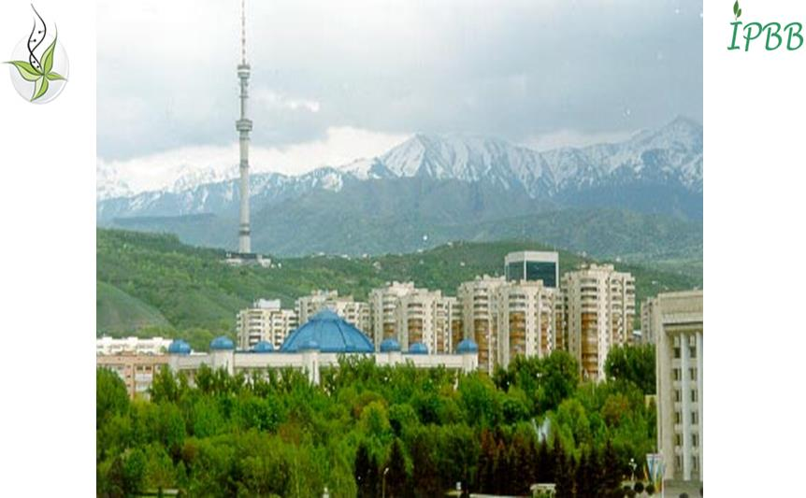
Welcome to 4th International Conference PlantGen 2017!!!
Conference venue:
Best Western Plus Atakent Park Hotel,
Timiryazev street 42, Almaty 050057, Kazakhstan
http://www.aphotel.kz/index.html

This four-start hotel is located in 10 minutes’ walk from the IPBB and the Main Botanical Garden, in 15 minutes’ walk from the al-Farabi Kazakh National University, and 30 min from the Airport by car.
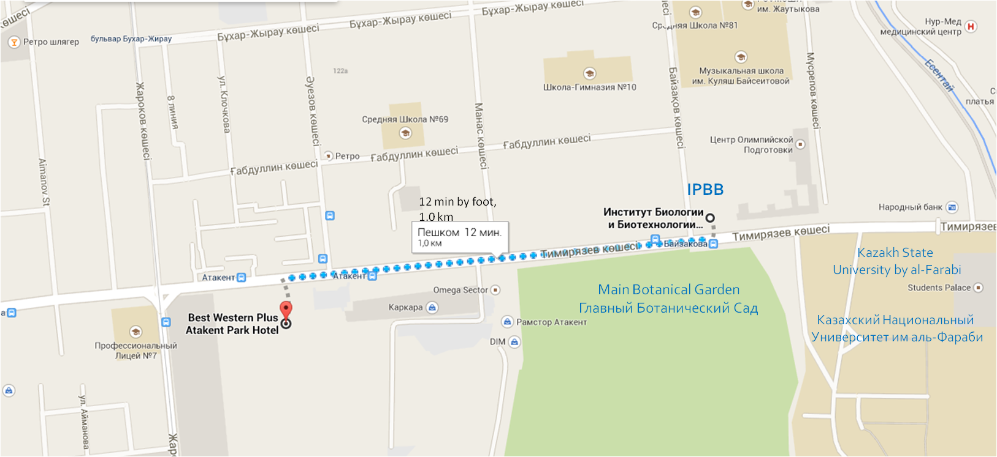
Map with locations of the Hotel “Best Western Atakent Park Hotel”
and Host Research Institute (IPBB)

Registration form
for participation at the 4th PlantGen2017 Conference,
Almaty, Kazakhstan, May 29 – June 2, 2017
Last Name
First Name
Middle Name
Country
Scientific degree
Position
Name of the Organization
Address of the Organization
Fax
Email address
Title of the abstract

Preferable session
Desired type of presentation (oral/poster)
Need help to book an accommodation (yes/no)

Requirements for abstract submission
Abstracts will be published in the Materials of the Conference. The total volume of the abstract should not exceed one page of A4 format. The file should be prepared in Microsoft Word format, Times New Roman, size 12, interval 1, with 2 cm margins.
Deadline for abstracts is March 1st, 2017. Abstracts received after March 1st, 2017, will not be included in the Materials of the Conference.
Selected papers will be submitted to “BMC Plant Biology” journal.
Poster size should not exceed 90Wх120L см.

Registration fee
The fee will cover Materials of the Conference, accesses to plenary session, all four working sessions, coffee-breakes, Welcome Party, Conference Banquet, and ski resort trip.
Early bird (before December 31, 2016) registration fee is 350 US dollars (USD).
Regular registration fee (before March 1, 2017) is 400 USD,
Late registration fee (after March 1, 2017) is 450 USD.
The registration fee should be paid by bank transfer to bank account of the conference’s technical operator: NJ Company Ltd (details provided below):

Bank accounts of the operator for bank transfers:
In US Dollars: | Beneficiary Bank name: Kazkommertsbank,  Bank address: Almaty, Kazakhstan  Account number: KZ439261802154390001  SWIFT: KZKOKZKX  Corresponding Bank:  Bank of New York, New York, USA  SWIFT: IRVT US 3N  Corresponding Account: 890 0223 057
In EUR: | Beneficiary Bank name: Kazkommertsbank,  Bank Address: Almaty, Kazakhstan  SWIFT: KZKOKZKX  Account number: KZ869261802154390003  Corresponding Bank Name:  "Commerzbank AG"  Frankfurt, Germany  SWIFT: СОВАDEFF  CORR/ACC: 400/8866048/01
In Russian rubles (RUB): | Название банка бенефициара: AO «Казкоммерцбанк»  Адрес банка: Алматы, Казахстан  р/с: KZ169261802154390002  SWIFT: KZKOKZKX  Корреспондентский банк в России:  к/с 30111810400000000059  "Сберегательный Банк Российской Федерации"  Москва, Россия  ИНН 7707083893  к/с 30101810400000000225 в РКЦ ГУЦБ РФ  БИК: 044525225  SWIFT: SABRRUММ012
Transfer beneficiary name (operator of the conference): NJ Company
Address of the company: Zharokov str. 292/110, Almaty 050060, Kazakhstan
Email address: reg_PlantGen2017@njcompany.kz
Web address: http://njcompany.kz/
Purpose of the transfer: PlantGen2017 conference and your NAME.

Confirmation of registration payment should be sent as a scanned copy entitled according to the name of participant and number of session (for instance – Jacobs_S_2_payment) to the email address: reg_PlantGen2017@njcompany.kz
The subject of the letter according to the name of participant and number of session: Jacobs_S_payment.
For cancellation of registration, please send a written request to the Organizing Committee Secretariat by e-mail. The amount of refund will be made according to the date when the cancellation request is received.

 | By December 31, 2016 | By April 1, 2017 | AFTER April 1, 2017
Registration Fee | 100% Refund (minus bank commission) | 50% Refund (minus bank commission) | No Refund

Conference program (under development)
May 29, 2017
10.00-14.00 Registration
14.00-14.30 Opening ceremony
14.30-16.00 Introduction on development of plant genetics and biotechnology inin Kazakhstan
16.00-17.30 Reports on integration of scientific activities in CIS countries
18.00-20.00 Welcome reception (you will enjoy folk music, songs and dances)
May 30, 2017
Plenary sessions. The list of confirmed speakers and titles of presentations.
Session 1. Genetic Resources and Evolution.
Speaker 1. N. Goncharov (Institute of Cytology and Genetics, Russia). “Taxonomy and molecular phylogeny of the genus Triticum L.”
Speaker 2. F. Blattner (IPK, Germany) "The evolution of the wheat grasses: Coenogenome vs. taxonomic diversification"
Speaker 3. X-J. Ge (South China Botanical Garden, CAS, China) “DNA barcoding of the Chinese Desert Flora”
Session 2. Genetics of Resistance to Stresses and Grain Quality.
Speaker 1. S. Griffiths (John Innes Centre, United Kingdom) “Global journeys of adaptive wheat genes”
Speaker 2. R. Tuberosa (University of Bologna, Italy) “Harnessing the root QTLome for enhancing cereal productivity and sustainability”
Speaker 3. T. Fahima (Haifa University, Israel) "Diversity and evolution of disease resistance genes derived from wild emmer wheat"
Session 3. Genomics, Phenomics and Bioinformatics.
Speaker 1. Q. Zhang (Huazhong Agricultural University, China) “Green goals and green technologies for future plant breeding”
Speaker 2. M. Ganal (TraitGenetics GmbH, Germany) “High throughput genotyping for plant research and breeding”
Speaker 3. M. Chen (Zhejiang University, Hangzhou, China) “Integrative bioinformatics approaches for cellular interactome modelling of rice”
Session 4. Genetic Engineering and Crop Improvement.
Speaker 1. J. Kumlehn (IPK, Germany) “Genome engineering in cereals”
Speaker 2. T. Komatsuda (NIСS, Japan) “The potential of barley/wheat orthology to advance cereal grain yield”
Speaker 3. B. Wulff (John Innes Centre, UK) “Rapid gene cloning in wheat”

May 31, 2017
Before lunch: Tour to ski resort “Shymbulak” (includes ropeway car travel).
After lunch: Short bus tour in central Almaty
16.00-19.00 Poster session and observation of scientific products demonstrated by sponsors of the conference
June 1, 2017
Parallel sessions 1 and 2
Session 1. Genetic Resources and Evolution.
Sub session 1.1 Preservation and study of genetic resources of agricultural crops.
Chairman – Prof. N. Goncharov (Institute of cytology and genetics, Novosibirsk, Russia)
Sub sessions 1.2 DNA barcoding of wild flora and molecular taxonomy
Chairman – Prof. F. Blattner (IPK, Gatersleben, Germany)

Session 2. Genetics of Resistance to Stresses and Grain Quality.
Sub session 2.1 Plant resistance to stressful environmental conditions
Chairman – Prof. Y. Uga (Institute of Crop Science, Tsukuba, Japan)
Sub session 2.2 Aspects of crop adaptation and quality improvement
Chairman – Prof. А. Abugalieva (Kazakh Institute of Agriculture and Crop Production, Almaty region, Kazakhstan)

Along with sessions 1 and 2 we plan following events:
11.00-13.00 – Meeting of geneticists and breeders of Kazakhstan (supported by IPBB)
14.00-16.00 – Workshop by Li-Cor company (supported by LabInstruments)

June 2, 2017
Parallel sessions 3 and 4
Session 3. Genomics, Phenomics and Bioinformatics.
Sub session 3.1. Modern approaches in genotyping of agricultural crops
Chairman – Dr. R. Kalendar (National Center of Biotechnology, Astana, Kazakhstan)
Sub session 3.2.New generation sequencing technologies for genetics and breeding
Chairman – Dr. M. Ganal (TraitGenetics GmbH, Gatersleben, Germany)
Session 4. Genetic Engineering and Crop Improvement.
Sub session 4.1. Modern biotechnologies for improvement of cultivated crops
Chairman – Dr. R. Omarov (Eurasian University by N. Gumilev, Astana, Kazakhstan).
Sub session 4.2. New technologies in plant genetic engineering
Chairman – Dr. S. Toki (Institute of agrobiological sciences, Tsukuba, Japan).

18.00. Conference Closure

19.00. Conference Banquet
(you will enjoy folk music, songs and dances)

Announcement on Accommodation booking
Starting from January 1st, 2017 the Best Western Plus Atakent Park Hotel is providing discount for participants of PlantGen 2017 international conference:
Price for Single room – 18 000 /night
Price for double room – 23 000/night.
You may book the room yourself by contacting the Hotel directly and using key words PlantGen 2017, or via the organizing committee.
In order to book your room via the organizing committee you should provide us your name and arriving/departure time and days details.

The venue of the 4th PlantGen2017:

Best Western Plus Atakent Park Hotel
Timiryazev street 42, Almaty 050057
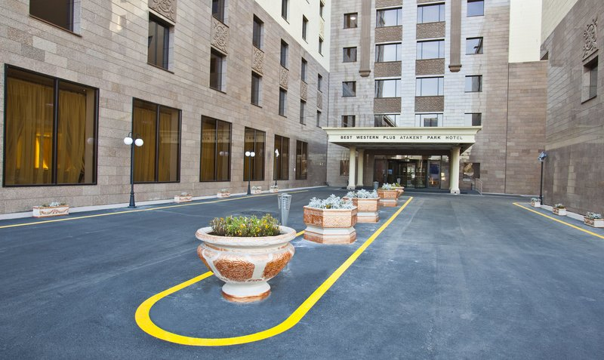
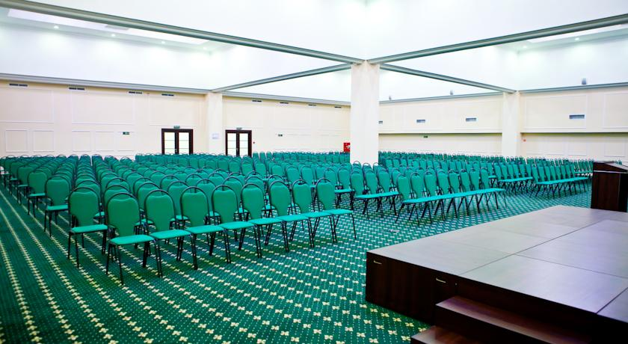
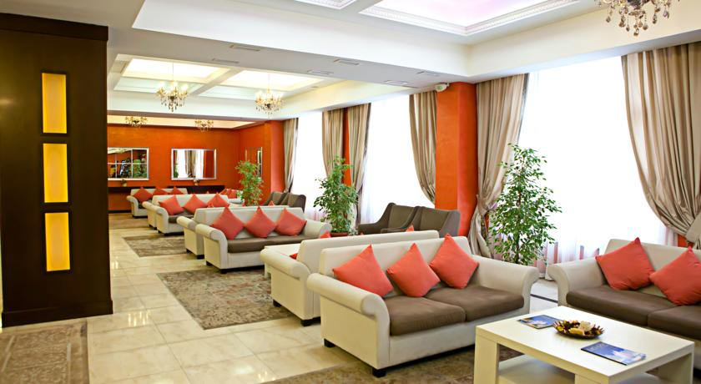

Sincerely Yours,

The Organizing Committee
of the 4th PlantGen2017 Conference
http://primerdigital.com/PlantGen2017/en/

