
Ministry of Science and Higher Education of the Republic of Kazakhstan
Science committee

«INSTITUTE OF PLANT BIOLOGY AND BIOTECHNOLOGY»
(IPBB)

Information letter No. 2
INTERNATIONAL CONFERENCE ON PLANT BIOLOGY AND BIOTECHNOLOGY 2024
(ICPBB 2024)
June 3–6, 2024

Conference Venue:
«Best Western Plus Atakent Park Hotel»
Timiryazev street 42, Almaty, Kazakhstan

Almaty, Kazakhstan

DEAR COLLEAGUES!

We invite you to participate in the International Conference on Plant Biology and Biotechnology (ICPBB 2024). The conference will be held on June 3–6, 2024, in Almaty, Republic of Kazakhstan. The conference topics will cover important issues, such as the study and rational usage of plant genetic resources, resistance to abiotic and biotic environmental stress factors, the development of new genomic, proteomic, and phenomic technologies, and genetic engineering research. The work of the conference will be divided into the following sessions:

Section 1. Genetic Resources and Biodiversity
Section 2. Genetics and Breeding
Section 3. Physiology, Biochemistry, and Biotechnology
Section 4. Cellular and Genetic Engineering
Section 5. Genomics, Proteomics, and Bioinformatics

Language of the conference: English

The Institute’s staff, Almaty city, and the high-mountain complex "Medeo" are waiting for you!

Organizing Committee

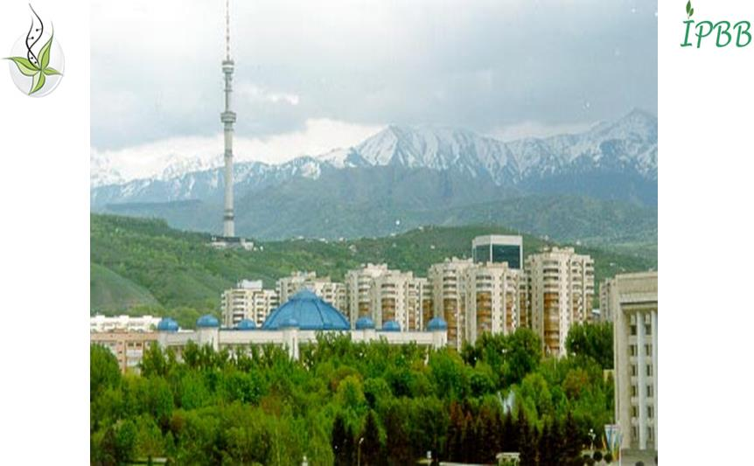
Welcome to Almaty, Kazakhstan!!!

Address for correspondence:
Kazakhstan, 050040, Almaty, Timiryazev St., 45,
Institute of plant biology and biotechnology
Organizing Committee of ICPBB 2024
Tel/Fax: 8 (727) 394-75-62
Email: icpbb2024@ipbb.kz
Website: https://primerdigital.com/ICPBB2024/

REGISTRATION FORM
For participants of ICPBB 2024, Almaty, Kazakhstan, June 3–6, 2024
Surname
First name
Middle name (if any)
Country
Scientific degree
Academic title
Job title
Affiliation (full name)
Work/home phone
Postal address with zip code
E-mail
Title of presentation
Session number and full name
Presentation form (Oral/Poster)
Need to book a hotel room (Yes/No)
Participation in a banquet (Yes/No)
Paid separately

Please, send the filled registration form to icpbb2024@ipbb.kz

Requirements for the publication of materials
The deadline for accepting abstracts is March 1, 2024. Materials received after March 1, 2024, as well as those without confirmation of registration fee payment, will not be considered by the Organizing Committee.
Information about the acceptance of abstracts will be available after April 1, 2024.

Requirements for the preparation of abstracts
- The volume of the abstract text (in English) should not exceed one A4 page in MS Word.
- Margins: all sides – 20 mm, line indent – 1 cm, font – Times New Roman, font size – 12 pt, single spacing.
- Latin names of species and genes should be italicized.
In the title of the abstract file and the subject of the letter, please use the surname of the first author in Latin transliteration indicating the section number, for example, Griffiths_2_abstract.
Please, send your abstracts to icpbb2024@ipbb.kz

Registration fee
for participants from Kazakhstanand neighboring countries (CIS):

- Early registration (until March 1, 2024) – 100 US dollars in tenge at the rate of the National Bank of the Republic of Kazakhstan on the day of payment;
- Later registration (after March 1, 2024) – 150 US dollars in tenge at the rate of the National Bank of the Republic of Kazakhstan on the day of payment.
Registration fee for young scientists (Bachelor, Master and Ph.D. students only – an official document confirming your status is required) – the equivalent of 50 US dollars (early registration) and the equivalent of 100 US dollars after March 1, 2024.

for participants from abroad:
- Early registration (until March 1, 2024) – 300 US dollars;
- Later registration (after March 1, 2024) – 400 US dollars.

The bank transfer fee should be covered by the conference participant!
The registration fee covers participation in the plenary and parallel sessions and poster section, conference materials, coffee breaks, and a tour of Almaty.

Bank transfer details:
In Tenge (local currency): | Получатель: РГП на праве хоз.вед Институт биологии и биотехнологии растений КН МНВО РК  БИН 061240005348  АО «БанкЦентрКредит»  г. Алматы 050012  ИИК KZ078562203131997837  БИК KCJBKZKX  Кбе 16, КНП 859
In US Dollars | Beneficiary: Institute of Plant Biology and Biotechnology.  Beneficiary Bank name: JSC BANK CENTERCREDIT, ALMATY KZ ,  Bank address: Almaty 050012, Kazakhstan  SWIFT: KCJBKZKX  Beneficiary Account: KZ748562203231997908  Corresponding Banks:
  JP MORGAN CHASE BANK, N.Y.
  SWIFT: CHASUS33
  Corresponding Account: 400951258
  CITIBANK, N.Y.
  SWIFT: CITIUS33
  Corresponding Account: 36017197
  ТHE BANK OF NEW YORK MELLON
  SWIFT: IRVTUS3N
  Corresponding Account: 8900587520
  DEUTSCHE BANK TRUST COMPANI AMERICAS, N.Y.
  SWIFT: BKTRUS33
  Corresponding Account: 04411595
  Kookmin Bank (from Kookmin Bank clients)
  SWIFT: CZNBKRSE
  Corresponding Account: 790-8-USD-01-1
In Russian currency: RUB (Russian rubles) | РГП на праве хоз.вед вед Институт биологии и биотехнологии растений (ИББР) КН МНВО РК  БИН 061240005348  АО «БанкЦентрКредит»  г. Алматы 050012  ИИК KZ728562203331997863  SWIFT: KCJBKZKX  Кбе 16, КНП 859  Корреспондентский банк:
  АО "Райффайзенбанк" SWIFT: RZBMRUMM
  к/с 30111810900000000085 БИК 044525700, к/с 30101810200000000700 к/с в ГТУ Банка России
  «Азиатско-Тихоокеанский Банк» (АО)
  к/с 30111810700000077822 БИК 041012765, к/с 30101810300000000765 в Отделении Благовещенск
  АО «Кредит Европа Банк» к/с 30111810900010010932 БИК 044525767, к/с 30101810900000000767 в ГУ Банка России по ЦФО
In EURO | Beneficiary: Institute of Plant Biology and Biotechnology.  Beneficiary Bank name: JSC BANK CENTERCREDIT, ALMATY KZ,  Bank address: Almaty 050012, Kazakhstan  SWIFT: KCJBKZKX  Beneficiary Account: KZ788562203231997933  Corresponding Banks:
  COMMERZBANK AG (do not use for the payment from/to Russia)
  SWIFT: COBADEFF
  Corresponding Account: 400886874700EUR
  DEUTSCHE BANK AG
  SWIFT: DEUTDEFF
  Corresponding Account:: 9499377
  RAIFFEISEN BANK INTERNATIONAL, VIENNA SWIFT: RZBAATWW
  Corresponding Account: 000-55.036.222

For cancelation of the registration fee, please send a message to the Organizing Committee by email letter to icpbb2024@ipbb.kz
The amount of money returned will depend on the date of the cancellation (see Table below).

 | Before April 1, 2024 | After April 1, 2024
Registration fees | 50% of fees (minus bank’s commission fee) | No refunding

The Organizing Committee of the ICPBB 2024 is open for sponsoring support; please get in touch with the organizers.

Sincerely Yours,
Organizing Committee
of the ICPBB 2024

